Hi Friends,

Sincere apologises for the delay in sending you over this little resource pack. It was so lovely meeting you all during the last weekend in June. It was also a joy to share my learnings and learn so much from you all. As promised please find below some resources and templates for the energy management and mindfulness home practice for your adolescent clients.

Kindest regards,

Kati

The bean bags for those who asked about where I got my ones from: <https://www.outdoor.ie/product/extreme-lounging-outdoor-bean-bag-grey/>

Expensive, but comfy and you can wipe it clean.

Earphone device for sound processing difficulties: IQ2Buds <https://www.nuheara.com/>

Place to learn more about the practice of Insight Dialogue <https://insightdialogue.org/> and guidelines <https://insightdialogue.org/relational-practices/insight-dialogue/guidelines/>

Videos:

Shauna Shapiro : what you practice grows stronger <https://youtu.be/IeblJdB2-Vo>

Step Inside the Circle short video https://www.youtube.com/watch?v=FVxjuTkWQiE

Step Inside the Circle long video

ACE’s questionnaire

https://www.npr.org/sections/health-shots/2015/03/02/387007941/take-the-ace-quiz-and-learn-what-it-does-and-doesnt-mean?t=1655553581591

Wisdom of Trauma movie trailer from Gabor Mate

https://thewisdomoftrauma.com/about-the-film/

Wampold and Fonagy in The great psychotherapy debate - https://www.youtube.com/watch?v=U5fhhAZnduU

Books:

The power of showing up – Dan Siegel (great for parents- attachment strengthening)

Beyond Behaviors – Mona Delahooke (helping our clients with behavioural difficulties, I share this with parents too)

The Presence Process – Michael Brown (for those wanting to strengthen presence awareness)

Altered Traits-Goleman and Davidson (more on science behind mindfulness)

The Mindful Therapist-Dan Siegel (the title says it all)

Recovering from Trauma- Deborah Lee (Self-help book using Compassion Focused Therapy)

Windows to Our Children- Violet Oaklander (Gestalt way of using creative methods with children)

Mindfulness Practices:

All in the the app Mindfulness Based Living Course or MBLC-YA (teens)– free to download on any app store on your phone device. Please feel free to share with your clients.

The practices we did were: RECOGNISING THE UNSETTLED MIND, SGRS (settling, grounding, resting with the support of sounds), BODY SCAN, 3 MINS BREATHING SPACE, Kindness to other and self (all in the mindfulness section of the app)

For those interested in colour I have this excerpt I took from Tsem Rinpoche website:

“…Here it is relevant to note that each of these five Buddhas and their associated colors are said to further the transformative process whereby specific human delusions are changed to positive qualities. Specifically it is believed that by meditating on the individual colors, which contain their respective essences, the following metamorphosis can be achieved:

- White transforms the delusion of ignorance into the wisdom of reality  
- Yellow transforms pride into wisdom of sameness  
- Blue transforms anger into mirror like wisdom  
- Red transforms the delusion of attachment into the wisdom of discernment - Green transforms jealousy into the wisdom of accomplishment

Hence we find that ancient Buddhism thought placed much emphasis on the spiritual significance of colors, which naturally influenced the development and practice of Buddhist aesthetics.”

Here is from a science website talking about lights appearing during meditation: https://nautil.us/the-ancient-peaceful-art-of-self_generated-hallucination-1825/#B115

AND for those that asked about colours in creative work:

Here is from a sensorimotor art therapy page <https://www.sensorimotorarttherapy.com/blog/2019/8/1/the-significance-of-colour>

Another one from an art therapy school <http://www.arttherapyblog.com/online/color-therapy-healing-an-introduction/>

CHECKING FOR ENVIRONMENTAL TRIGGERS (keep in mind that many triggers are not CONSTANT and it varies even in one single day…this is just a simple exercise to help us become more aware about how the environment MAYBE adding more to or causing dysregulation.

How the environment around me may be affecting my nervous system? What score would you give to it from 1 to 10?

Maybe use an A4 page per category.

Sounds:

I.e. Tv on while I am chatting with my mum (10)

Clock ticking (5)

Smells:

I.e. Certain foods being cooked – cabbage (10), fish (6), barbecued meat (3)

Texture:

I.e. Touching velvet materials (8), Eating mushy foods (10)

Taste:

I.e. Pineapple (10), broccoli (4), wine (4)

Seeing:

I.e. zebra patterns (8), open sky (10), flashing lights (5), sunny day (5), dark room (6), dimmed lights (10), vivid colours (3).

**Energy Management Planner**

|  |  |  |  |
| --- | --- | --- | --- |
| **Activities that will take away energy**  **Do the following equation:**  **Total of nourishing activities points minus total of withdrawing points to arrive at energy are you are left with.** | **1 to 10** | **Activities that will replenish energy** | **1 to 10** |

HOME PRACTICE

For _________ [client’s name] (training to regulate nervous system and return to window of tolerance)

Parent: _______ Use the picture I sent to show that the young person is out of their window of tolerance and are either and that the intention of this exercise is to help them to return back to their window of tolerance.

When I sense going out of my window of tolerance (unpleasant sensations arising in the body). I sit down and close my eyes (if possible) and investigate:

1. **What sensations do I feel in my body?**

**Anna in session you spoke about feeling a knot in your tummy. Maybe at home you may feel something different, put your researcher hat on and notice what is happening with your body (remember...then your brain does not need to try to save you from the sensations by creating more worrisome thoughts)**

**If you do not know or is finding hard to notice sensations, than maybe using the menu of sensations below may help.**



STAY WITH THE SENSATIONS FOR A FEW MINUTES (8 minutes or more) …NOTICE WHAT IS HAPPENING WITH THE SENSATIONS:

Getting bigger or smaller

Moving around or is static

What material it feels like it is made of?

What colour?

Is it spreading to other areas?

Is all of the above changing as you stay with the sensation?

We are teaching the brain that the sensations are not dangerous and that we can stay with them without needing to fight, ignore or get rid of them because we know that the sensations will go away on their own time.

1. **How can I help my nervous system right now?**

**Use the menu below to see what calming activities you can do.**

Ie. Placing your hands in your tummy as you did in session or maybe you want to try something different like:

Bear hugging yourself

Hugging yourself, but placing your hands under your armpits

Squeezing your hands together

Placing your hands behind your neck

Pressing the ground firmly with your feet

**YOU NEED TO TRACK THE change from unpleasant to a bit more PLEASANT SENSATION.**

**Below is another list of other calming activities you can choose**

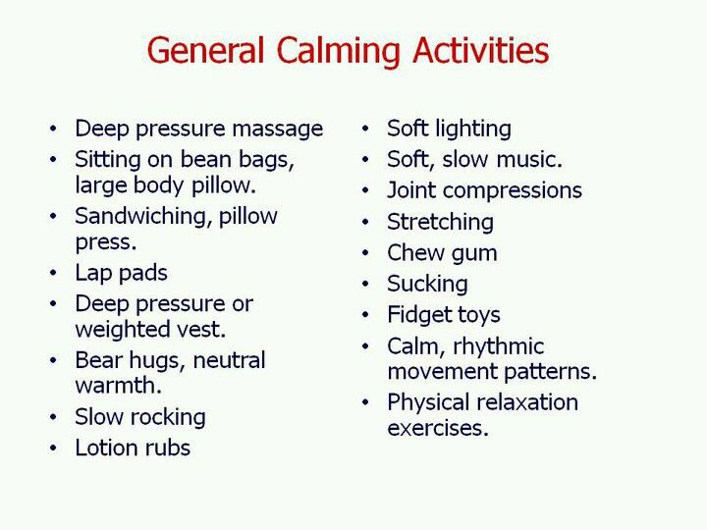

At the end of this practice shake it off a bit, or stretch your body, or go for a walk.

For parents:

In sessions I speak about the power of co-regulation. Mirror neurons. Menu for

parents on soothing practices (take a break, breathe, reset then return)

I share videos for them to watch at home:

Dan Siegel

How our relationship shapes us

<https://youtu.be/fwmtgrWKQrY>

And Brainstorm: the power and purpose of the teenager brain

<https://youtu.be/H1pf1xTMUng>

WORKING WITH ANGER = CIRCUIT BREAKER









**Experiment to prevent meltdowns/burn out**

From the practices we have done on both days or from past experience, have you noticed any sensory input that you many find a bit unpleasant? Can you give it a score from 1 to 10?

Example:

Begin with how is the environment impacting you

Auditory/Sounds: clock ticking (8), people chewing loud (10), dog barking (8)

Tactile/touch: velvet (10), labels on clothing (8), sand (6), light touch (8)

Visual: zebra pattern (10), bright light (6)

Taste/smell: petrol (6), grainy food (8)

Vestibular/movement: high places (10), escalators(7),

Move to the activities you have done today and how much they took away from your battery

College lecture (10)

Trying to finish assignment (8)

Fight with dad (10)

Resourcing activities that you have done today on the right side

Mindfulness (10), Spraying Lavender (8), Bath (7), Hugging myself (5), painting (6),

Watching Netflix with my friend online (10), hanging out with friends (10).

Do the maths for today:

What are the things that you need to do to resource yourself so there is a balance in your energy accounting sheet?

Make a list of what stresses you so you can plan your day better

Mindful awareness really helpful to discover what are the environmental triggers in your world of experience.

Energy Accounting (sensory input minus resourcing or calming activities = less meltdowns)

Energy Accounting: <https://vimeo.com/213640278>

**You will never speak to anyone**

**More than you speak to yourself**

**In your head.**

**Please be Kind to Yourself.**